ACTUARIAL INTERACTIONS CALCULATOR (AIC – AFRICA EDITION)

Pan-African Actuarial Modeling & Risk Intelligence Platform

Prepared by: Tinotenda F Chewe
Email: tinotendafidelis45@gmail.com

1. EXECUTIVE SUMMARY
The Actuarial Interactions Calculator (AIC) – Africa Edition is a scalable, cloud-based actuarial modeling and risk automation platform designed specifically for emerging and developing insurance markets across Africa.
Unlike legacy actuarial systems built for stable, data-rich Western markets, AIC is engineered to operate effectively in:
- Data-sparse environments
- High-inflation economies
- Multi-currency systems
- Rapidly evolving regulatory landscapes
- Microinsurance-driven markets
The platform integrates actuarial science, financial modeling, stochastic simulations, regulatory alignment, and AI-enhanced analytics into a unified enterprise system.
AIC is positioned as:
- A replacement for fragmented Excel-based workflows
- A cost-efficient alternative to expensive legacy software
- A digital transformation platform for African insurers
- A scalable infrastructure for cross-border insurance groups

2. AFRICAN INSURANCE LANDSCAPE ANALYSIS
2.1 Structural Market Realities
African insurers face unique systemic challenges:
- Incomplete mortality tables
- Sparse historical claims data
- Currency volatility
- Hyperinflation exposure
- Regulatory inconsistency between jurisdictions
- Low actuarial workforce density
- Heavy reliance on spreadsheet models
Western actuarial systems assume:
- Clean datasets
- Stable economies
- Predictable mortality trends
- Deep capital markets
Those assumptions do not consistently hold in African markets.
AIC is engineered around African realities.

3. STRATEGIC DESIGN PRINCIPLES
The system is built on the following pillars:
- Data resilience
- Inflation adaptability
- Multi-currency support
- Regulatory configurability
- Cost efficiency
- AI-enhanced insight generation
- Cloud-first architecture
- Mobile-optimized accessibility

4. CORE SYSTEM ARCHITECTURE
4.1 Infrastructure
- Cloud-native deployment (AWS / Azure / regional cloud)
- Lightweight modular architecture
- API-first design
- Encrypted database storage
- Role-based access control
4.2 Modular Design
Modules can be activated based on insurer size:
- Core Pricing Engine
- Reserve Automation Module
- Stochastic Capital Model
- Microinsurance Pricing Engine
- Regulatory Reporting Module
- AI Risk Intelligence Layer
This allows scalability from small insurers to multinational groups.

5. AFRICA-OPTIMIZED FUNCTIONAL MODULES

5.1 Data Resilience & Sparse Dataset Engine
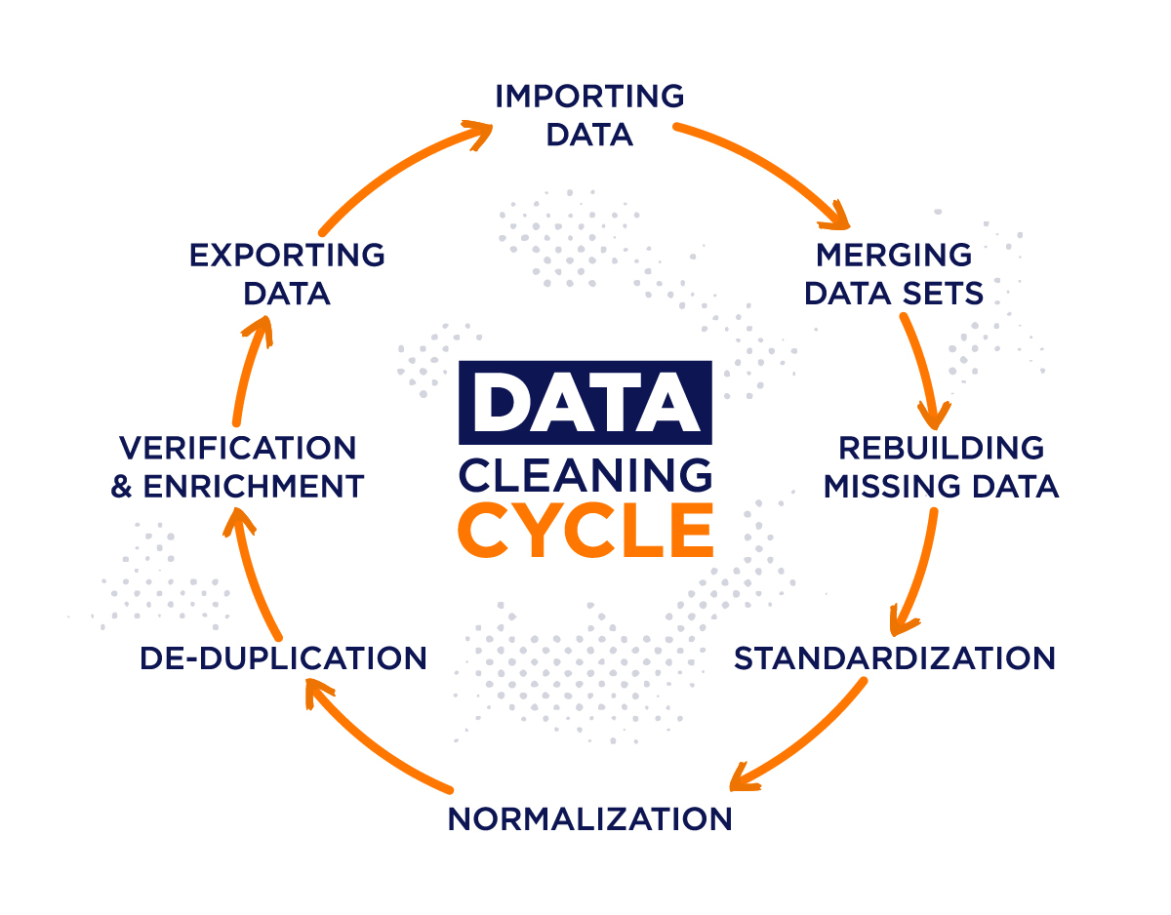
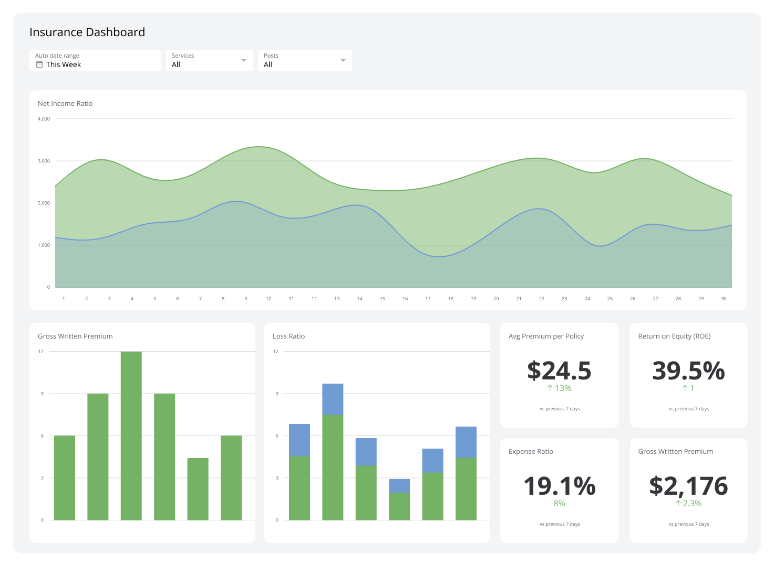
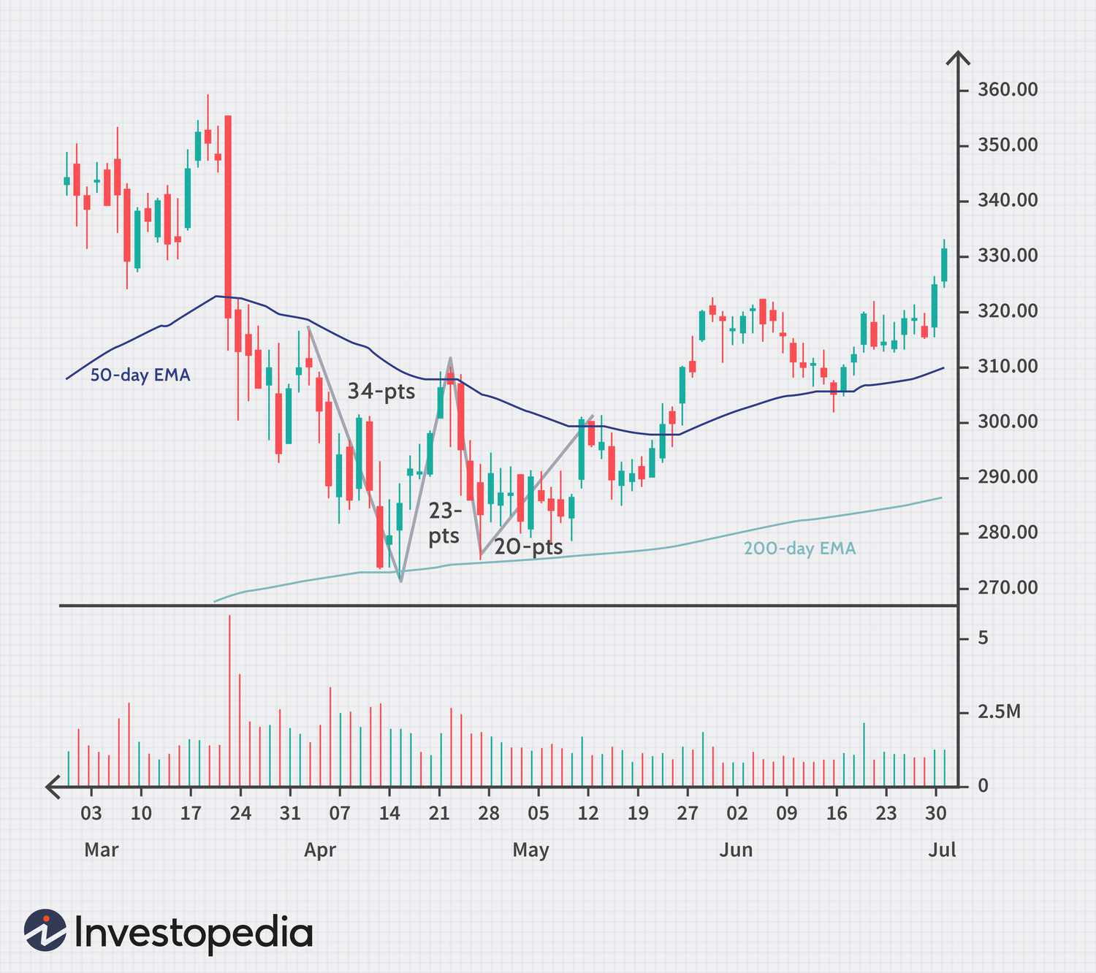
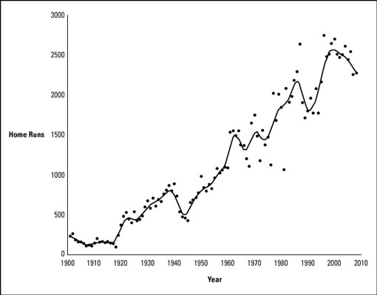
Capabilities:
- Data validation automation
- Missing data imputation
- Mortality smoothing algorithms
- Experience blending techniques
- Scaling factors for incomplete datasets
- Country-level mortality calibration
Designed to function when data is imperfect.
5.2 Multi-Currency & Inflation Shock Modeling
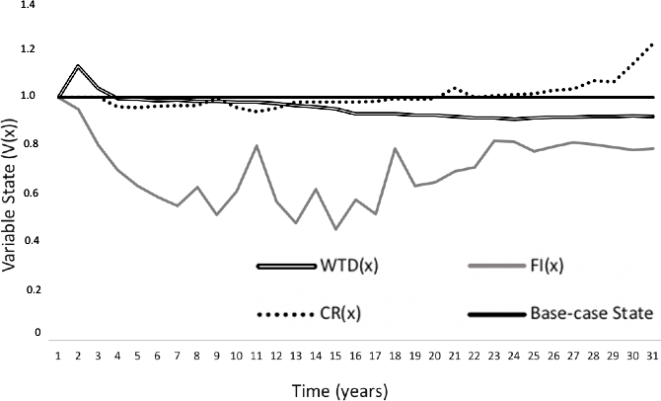
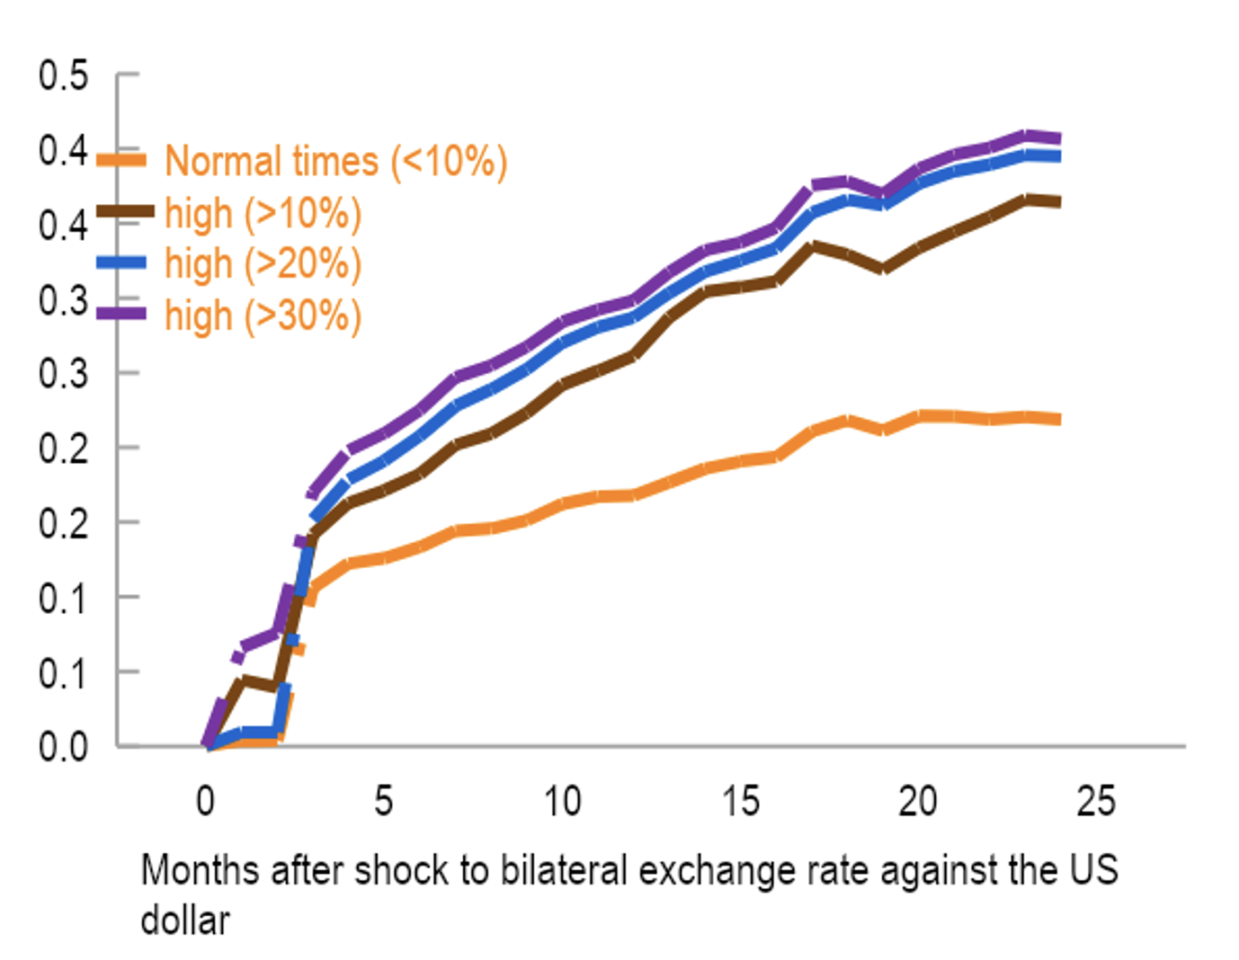

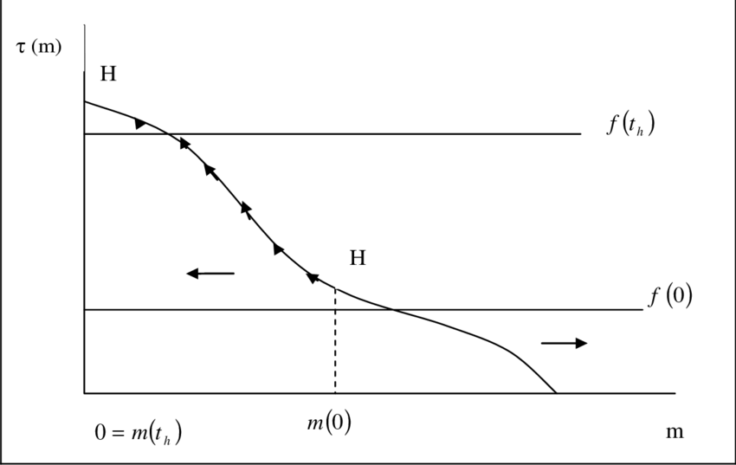
Features:
- Local currency pricing
- USD-indexed product modeling
- Hyperinflation scenario testing
- FX shock simulations
- Inflation-linked benefit projection
Supports environments such as Zimbabwe’s volatility and Nigeria’s currency shifts.

5.3 Microinsurance & Informal Market Pricing



Capabilities:
- Low-premium term life pricing
- Short-duration products
- Group scheme modeling
- High lapse sensitivity modeling
- Mobile premium collection integration
This supports Africa’s fast-growing microinsurance sector.

5.4 Advanced Risk & Capital Modeling
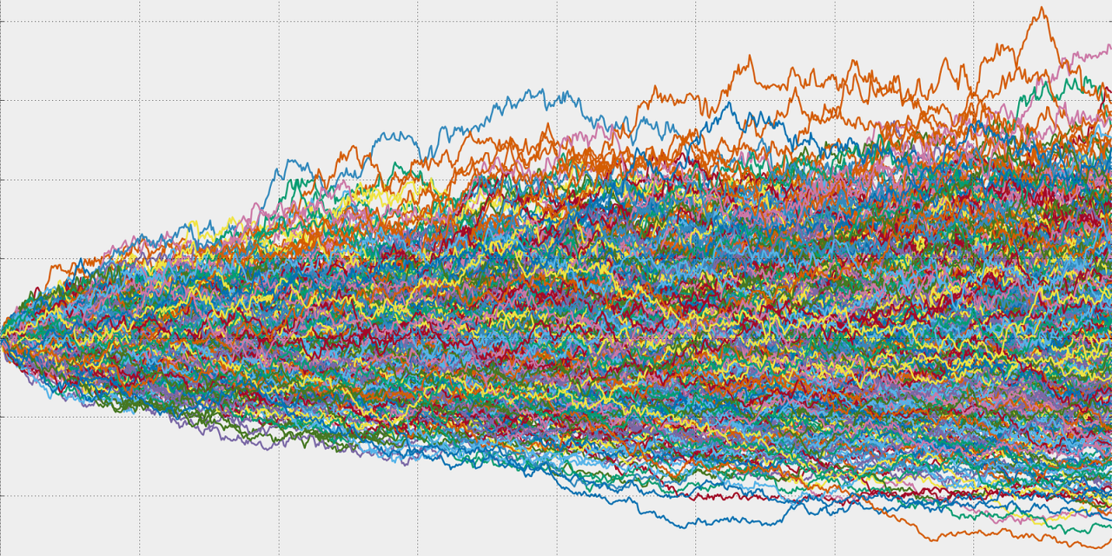
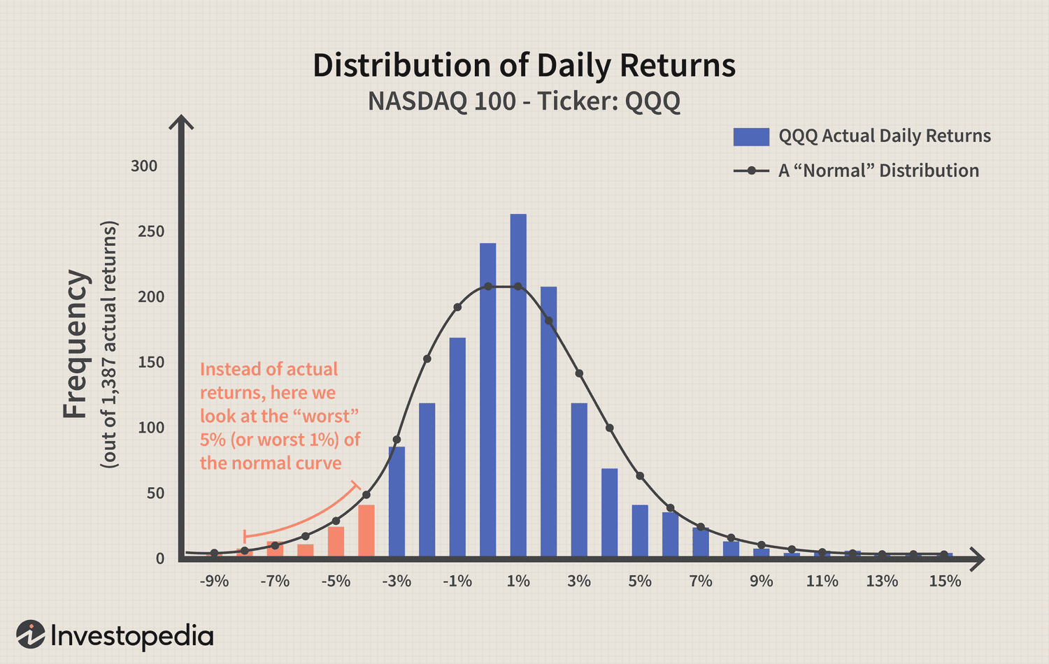

Includes:
- Monte Carlo simulation engine
- Value at Risk (VaR)
- Tail Value at Risk (TVaR)
- Capital stress testing
- Economic scenario generator
Adaptable to varying solvency regimes across African regulators.

5.5 Automated Reserve Modeling (Chain Ladder Engine)
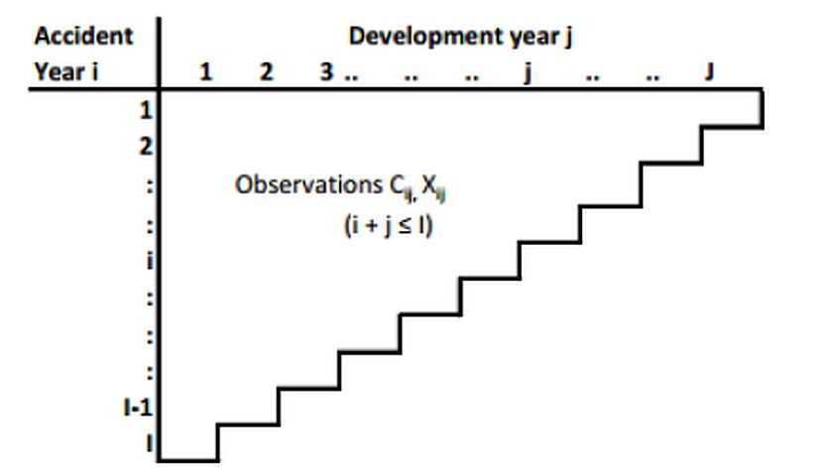
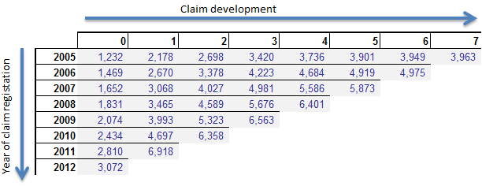
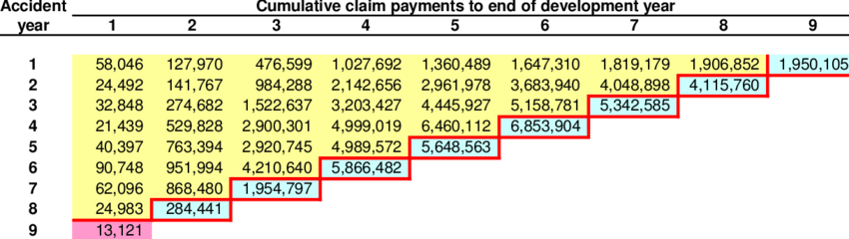
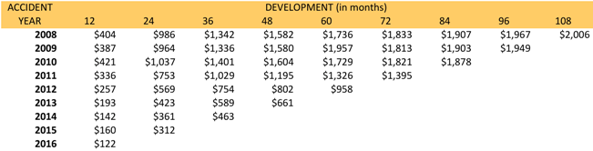
Features:
- Automatic claims triangle construction
- Development factor estimation
- Ultimate loss projection
- Quarterly rerun automation
- Audit-ready reserve reporting
Removes spreadsheet risk exposure.

5.6 AI-Driven Risk Intelligence Layer
Capabilities:
- Lapse prediction modeling
- Claims anomaly detection
- Mortality trend forecasting
- Portfolio risk clustering
- Sensitivity heatmaps
Combines actuarial science with machine learning to create predictive insights.
This is rare within African insurance ecosystems.

6. REGULATORY ADAPTABILITY
AIC includes configurable frameworks to support:
- South African solvency standards
- Zimbabwean regulatory guidelines
- Kenyan insurance regulatory frameworks
- Nigerian capital adequacy models
Country-specific modules can be activated without altering the core engine.

7. COST & ACCESSIBILITY ADVANTAGE
Unlike heavy enterprise systems:
- Modular licensing structure
- Cloud-based hosting reduces infrastructure cost
- No dependency on expensive proprietary engines
- Customizable per insurer scale
This makes it attractive to mid-tier and growing insurers across Africa.

8. CROSS-BORDER ENTERPRISE SUPPORT
For pan-African insurance groups:
- Consolidated group-level dashboard
- Subsidiary performance monitoring
- Country risk comparison analytics
- Centralized actuarial governance
Enables multi-country actuarial control from head office.

9. COMPETITIVE DIFFERENTIATORS
Feature | Legacy Systems | AIC Africa
Built for African Data Gaps | No | Yes
Hyperinflation Modeling | Limited | Advanced
Microinsurance Focus | Minimal | Core Feature
Modular Deployment | Limited | Yes
AI Integration | Rare | Integrated
Cost Structure | High | Scalable
Cross-Border Configurability | Complex | Built-in

10. STRATEGIC POSITIONING
AIC Africa is positioned as:
A continent-optimized actuarial infrastructure platform that modernizes pricing, reserving, and capital modeling for African insurers operating under volatile and data-constrained environments.
It does not simply replicate Western actuarial tools.
It adapts actuarial science to African market realities.

11. PROFESSIONAL CAREER IMPACT
Developing and presenting this system demonstrates:
- Deep actuarial understanding
- Systems architecture capability
- African market awareness
- Risk management insight
- Regulatory literacy
- Technical development competence
- Innovation leadership
This positions the developer not merely as:
“An internship candidate”
But as:
A digital actuarial transformation contributor.

12. SYSTEM INTEGRATION & ENTERPRISE ARCHITECTURE

12.1 API ARCHITECTURE DESIGN
12.1.1 Design Philosophy
The AIC Africa Edition platform is built using an API-first architecture. This ensures:
- Modular scalability
- Cross-system integration capability
- Mobile compatibility
- Interoperability with legacy insurer systems
- Secure data exchange
The system exposes RESTful API endpoints to allow:
- Policy pricing requests
- Reserve calculation triggers
- Scenario simulation execution
- Report generation
- Regulatory export

12.1.2 Example API Structure
Endpoint | Method | Description
/api/pricing | POST | Calculates policy premium
/api/reserve | POST | Runs reserve model
/api/mortality | GET | Retrieves mortality rates
/api/simulation | POST | Executes Monte Carlo
/api/report | GET | Generates valuation report

Example API Implementation (Flask)
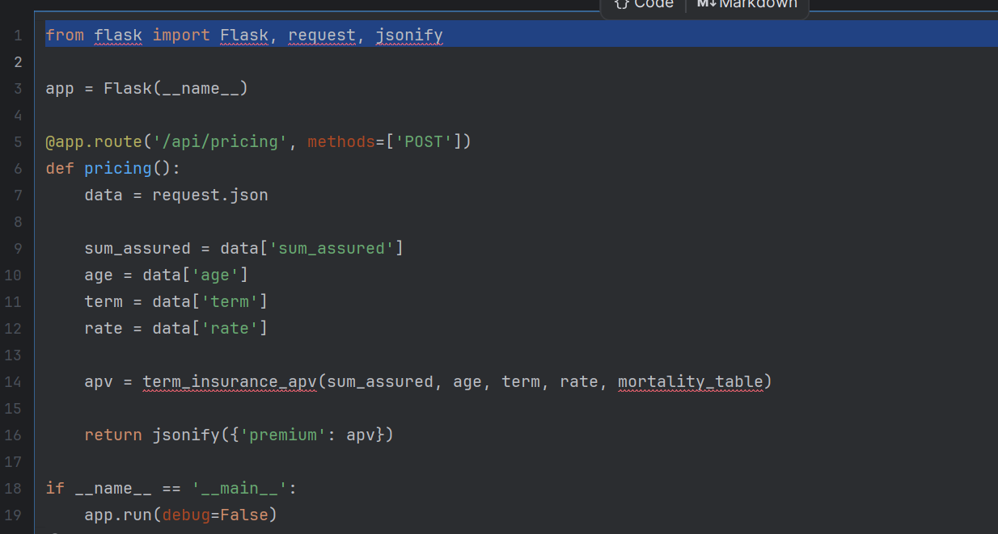

12.1.3 Enterprise Benefits
- Enables integration with mobile insurance platforms
- Allows regulatory systems to pull valuation data
- Supports multi-country operations
- Reduces system siloing

12.2 DATABASE SCHEMA BLUEPRINT
12.2.1 Database Design Principles
The database structure supports:
- Auditability
- Historical assumption tracking
- Regulatory traceability
- Multi-country configuration

12.2.2 Core Tables
1. Mortality_Table
- id
- country
- age
- qx
- effective_year
2. Policy_Data
- policy_id
- country
- product_type
- issue_age
- term
- sum_assured
- premium
3. Claims_Data
- claim_id
- policy_id
- claim_amount
- accident_year
- development_year
4. Assumptions_Log
- assumption_id
- parameter_name
- old_value
- new_value
- modified_by
- modification_date
5. Simulation_Results
- simulation_id
- run_date
- scenario_type
- var_value
- tvar_value

12.2.3 Audit Advantage
Each actuarial run is logged with:
- Timestamp
- User
- Assumptions used
- Model version
This directly supports governance and compliance frameworks.

14.3 CLOUD DEPLOYMENT STRUCTURE
12.3.1 Infrastructure Overview
The platform is designed for deployment on:
- AWS
- Microsoft Azure
- Regional African cloud providers
Architecture components include:
- Backend server (Docker container)
- PostgreSQL database
- Secure API gateway
- Load balancer
- Encrypted storage

12.3.2 Deployment Model
Containerization using Docker:
- Ensures portability
- Enables scalability
- Reduces infrastructure dependency
Example Dockerfile:
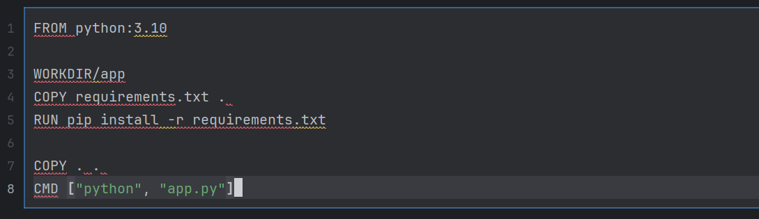

12.3.3 Security Framework
- HTTPS encryption
- Role-based access control
- Two-factor authentication
- Encrypted data at rest
- Regular model validation checks

12.4 IFRS 17 PROJECTION FRAMEWORK
12.4.1 Overview
IFRS 17 requires:
- Fulfilment cash flow calculation
- Risk adjustment
- Contractual service margin (CSM)
- Discounted future projections
(AIASB, 2017)

12.4.2 Projection Logic
The AIC projection engine models:
- Future expected cash inflows (premiums)
- Future expected outflows (claims & expenses)
- Discounting using yield curve
- Risk adjustment for non-financial risk
- CSM amortization over coverage period

Simplified IFRS 17 Projection Snippet
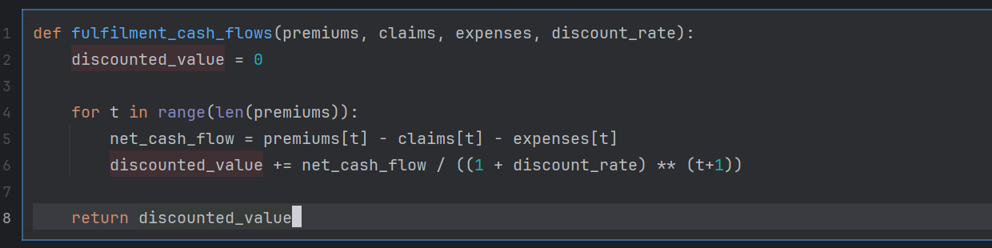

12.4.3 Risk Adjustment Example

12.4.4 Enterprise Impact
This enables:
- Regulatory compliance
- Transparent reporting
- Cross-border standardization
- Alignment with global financial reporting practices

13. STRATEGIC COMPETITIVE POSITIONING
The AIC Africa Edition competes on:
- Cost efficiency
- African market optimization
- Data resilience
- Regulatory configurability
- AI-enhanced analytics
- Cloud scalability
It is positioned not merely as a tool, but as:
A digital actuarial infrastructure platform.

12. CONCLUSION
The Actuarial Interactions Calculator – Africa Edition represents a scalable, adaptable, and forward-thinking actuarial modeling platform tailored to the continent’s insurance realities.
By integrating:
- Data resilience
- Inflation adaptability
- Microinsurance focus
- Regulatory configurability
- AI-enhanced modeling
It establishes a credible pathway toward continental actuarial modernization.

15. REFERENCES (HARVARD STYLE)
African Insurance Organisation (AIO) (2022) Insurance Market Developments in Africa. Available at: https://www.africaninsurance.org (Accessed: 28 February 2026).
International Accounting Standards Board (IASB) (2017) IFRS 17 Insurance Contracts. London: IFRS Foundation.
McKinsey & Company (2020) Insurance in Africa: Opportunities and Challenges. Available at: https://www.mckinsey.com (Accessed: 28 February 2026).
Mack, T. (1993) ‘Distribution-free calculation of the standard error of chain ladder reserve estimates’, ASTIN Bulletin, 23(2), pp. 213–225.
Moody’s Analytics (2021) Capital Modeling in Emerging Insurance Markets. London: Moody’s.
Swiss Re Institute (2023) World Insurance Sigma Report. Zurich: Swiss Re.
Venter, G. (2007) ‘Stochastic Claims Reserving Methods in Insurance’, Variance, 1(1), pp. 104–135.
Wüthrich, M.V. and Merz, M. (2008) Stochastic Claims Reserving Methods in Insurance. Chichester: Wiley.

